

|  |  |
| --- | --- |
| **Course Title:** | Signals and Systems I |
| **Course Number:** | ELE 532 |
| **Semester/Year (e.g. F2017)** | F2018 |

|  |  |
| --- | --- |
| **Instructor** | Dimitri Androutsos |

|  |  |
| --- | --- |
| ***Assignment/Lab Number:*** | Lab Assignment 3 |
| ***Assignment/Lab Title:*** | Lab Assignment 3 |

|  |  |
| --- | --- |
| ***Submission Date:*** | October 28, 2018 |
| ***Due Date:*** | October 28, 2018 |

|  |  |  |  |  |
| --- | --- | --- | --- | --- |
| **Student LAST Name** | **Student FIRST Name** | **Student Number** | **Section** | **Signature\*** |
| Patel | Parth | 500542681 | 03 | https://lh4.googleusercontent.com/RERTDzgBHlA5Iq8WGV9_ol-RPJ7GyaKTxuZEaGxeDq-K2XCQ3MXEKAY8iXpK8ceRJQ3pgl3nrZFprgA3DOKWhWSh3k9FHwKu0lAeFeLP3gf3s_asaTazF5Dh8jT2HtZ1-Cz0gUsa |
| Shreekant | Vatsal | 500771363 | 03 | https://lh6.googleusercontent.com/3HQdhqP6bDJc0yrkgrX2HXXQEpLNQI6oSFSgrHaKJ574vqvXcAIVqbt55MOMloPsxDN0ptT29rIoTak-JyQdDxYysL9uQolBLYN682_9y6dVzPQiwq6ni5LgZb0STdB93yavMJ4l |

*By signing above you attest that you have contributed to this written lab report and confirm that all work you have contributed to this lab report is your own work. Any suspicion of copying or plagiarism in this work will result in an investigation of Academic Misconduct and may result in a “0” on the work, an “F” in the course, or possibly more severe penalties, as well as a Disciplinary

Table of Contents

A.1…………………………………………………………………………………………

A.2…………………………………………………………………………………………

A.3…………………………………………………………………………………………

A.4…………………………………………………………………………………………

A.5…………………………………………………………………………………………

A.6…………………………………………………………………………………………

B.1…………………………………………………………………………………………

B.2…………………………………………………………………………………………

B.3…………………………………………………………………………………………

B.4…………………………………………………………………………………………

B.5…………………………………………………………………………………………

B.6…………………………………………………………………………………………

B.7…………………………………………………………………………………………

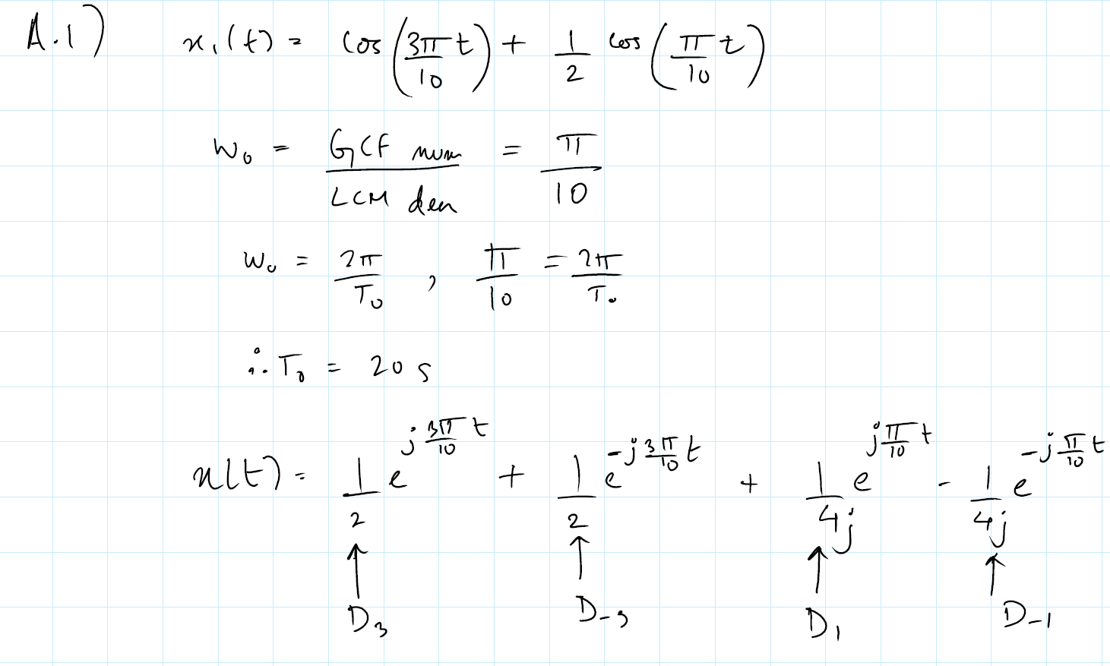

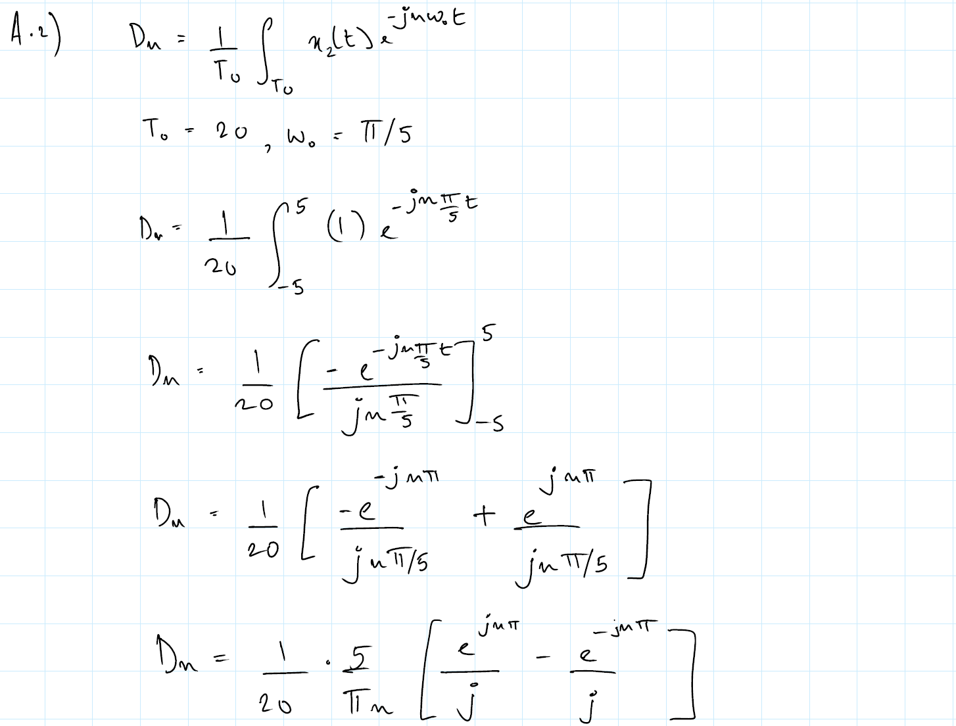

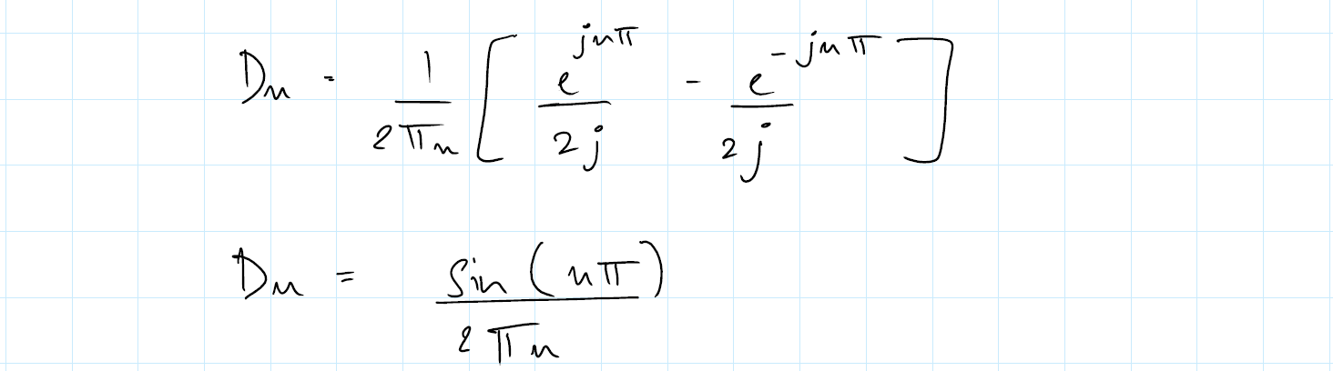

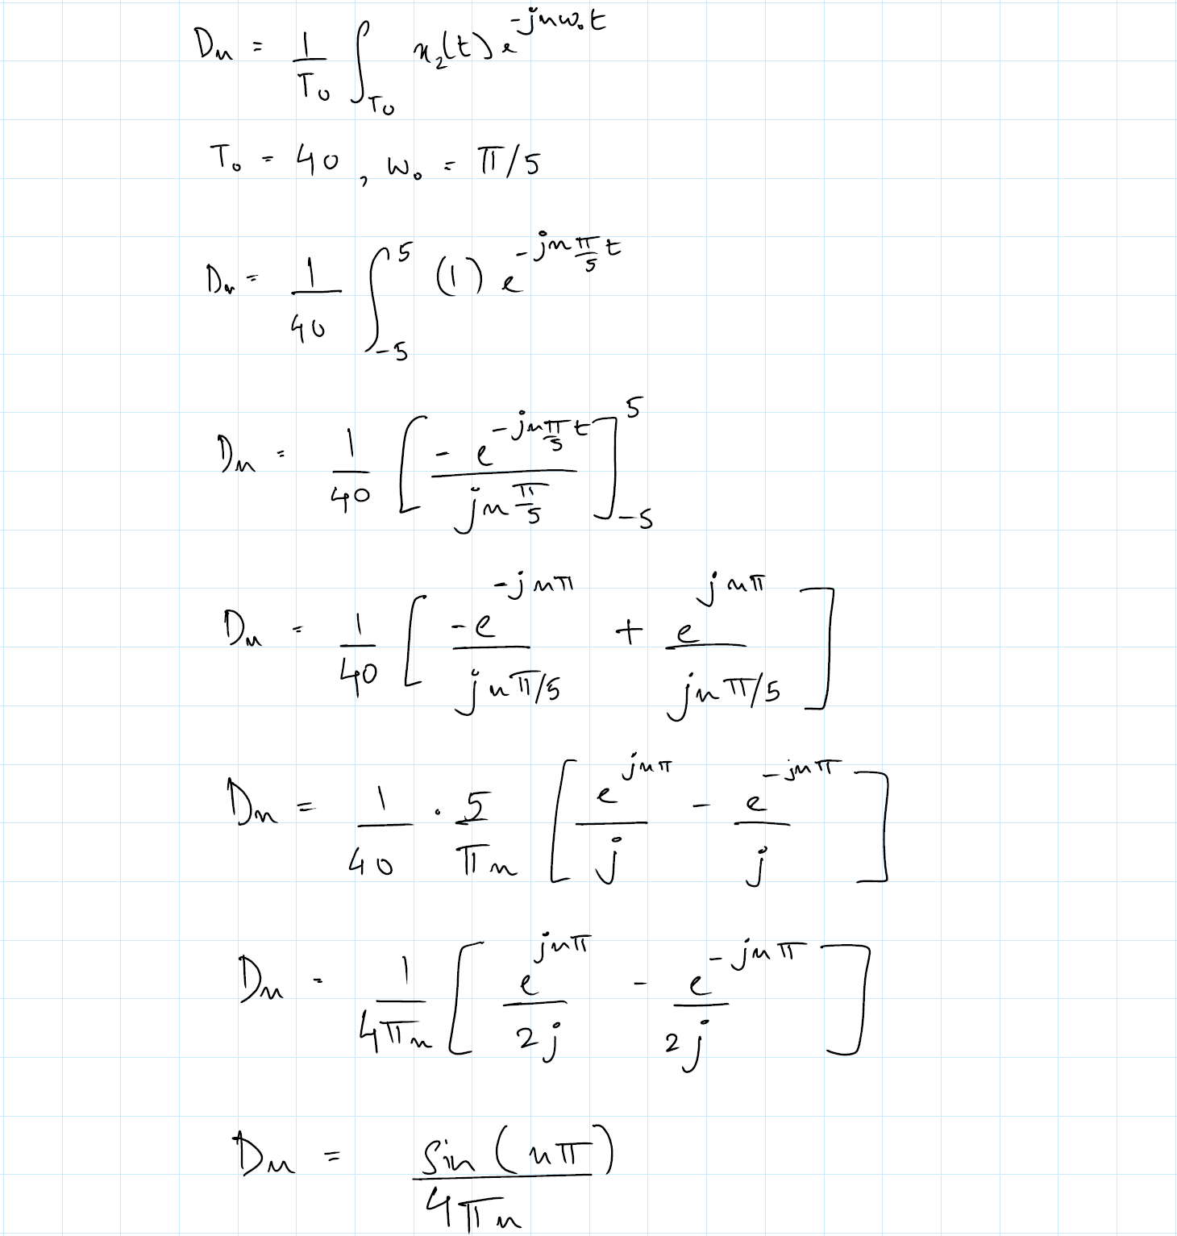

A.3

x2(t)

-5 ≤ n ≤ 5

clf; n = (-5:5); D_n = sin(n*pi)./(2*pi*n);  
 subplot(1,2,1); stem(n,abs(D_n),'.k');  
 xlabel('n'); ylabel('|D_n|');  
 subplot(1,2,2); stem(n,angle(D_n),'.k');  
 xlabel('n'); ylabel('\angle D_n [rad]');

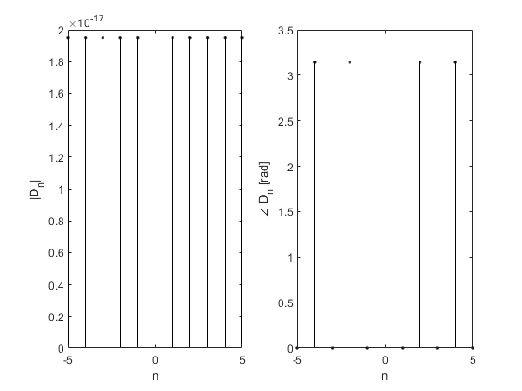

-20 ≤ n ≤ 20

clf; n = (-20:20); D_n = sin(n*pi)./(2*pi*n);  
 subplot(1,2,1); stem(n,abs(D_n),'.k');  
 xlabel('n'); ylabel('|D_n|');  
 subplot(1,2,2); stem(n,angle(D_n),'.k');  
 xlabel('n'); ylabel('\angle D_n [rad]');

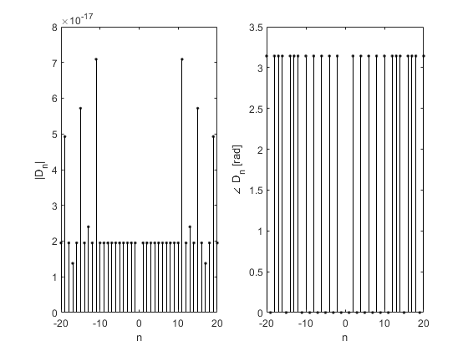

-50 ≤ n ≤ 50

clf; n = (-50:50); D_n = sin(n*pi)./(2*pi*n);  
 subplot(1,2,1); stem(n,abs(D_n),'.k');  
 xlabel('n'); ylabel('|D_n|');  
 subplot(1,2,2); stem(n,angle(D_n),'.k');  
 xlabel('n'); ylabel('\angle D_n [rad]');

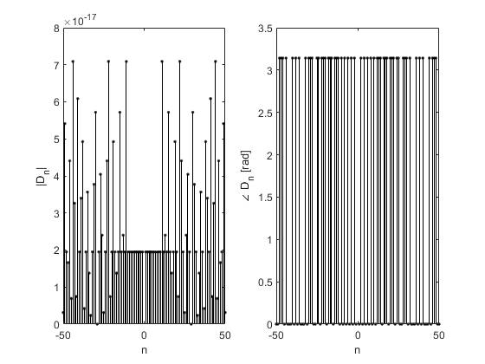

-500≤ n ≤ 500

clf; n = (-500:500); D_n = sin(n*pi)./(2*pi*n);  
 subplot(1,2,1); stem(n,abs(D_n),'.k');  
 xlabel('n'); ylabel('|D_n|');  
 subplot(1,2,2); stem(n,angle(D_n),'.k');  
 xlabel('n'); ylabel('\angle D_n [rad]');

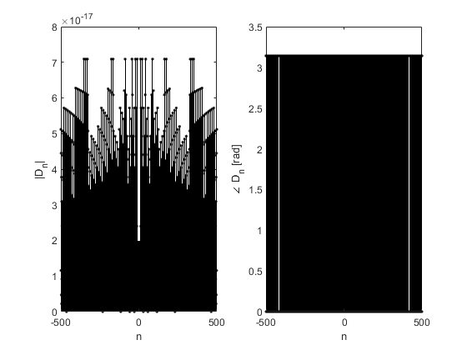

x3(t)

-5 ≤ n ≤ 5

clf; n = (-5:5); D_n = sin(n*pi)./(4*pi*n);  
 subplot(1,2,1); stem(n,abs(D_n),'.k');  
 xlabel('n'); ylabel('|D_n|');  
 subplot(1,2,2); stem(n,angle(D_n),'.k');  
 xlabel('n'); ylabel('\angle D_n [rad]');

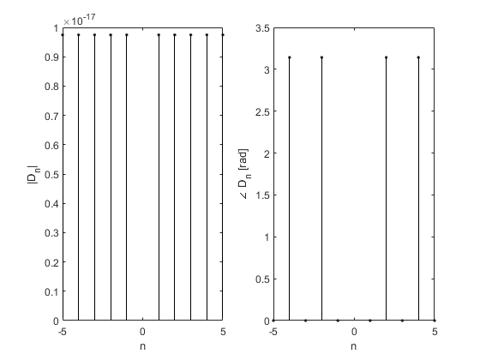

-20 ≤ n ≤20

clf; n = (-20:20); D_n = sin(n*pi)./(4*pi*n);  
 subplot(1,2,1); stem(n,abs(D_n),'.k');  
 xlabel('n'); ylabel('|D_n|');  
 subplot(1,2,2); stem(n,angle(D_n),'.k');  
 xlabel('n'); ylabel('\angle D_n [rad]');

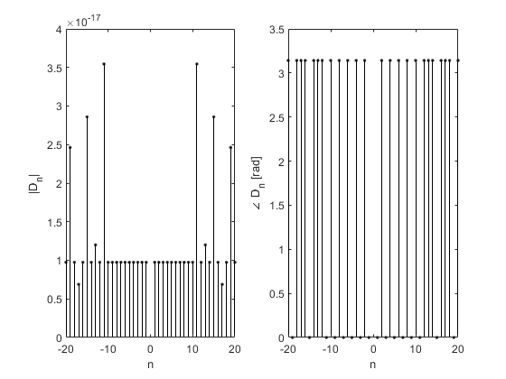

-50 ≤ n ≤ 50

clf; n = (-50:50); D_n = sin(n*pi)./(4*pi*n);  
 subplot(1,2,1); stem(n,abs(D_n),'.k');  
 xlabel('n'); ylabel('|D_n|');  
 subplot(1,2,2); stem(n,angle(D_n),'.k');  
 xlabel('n'); ylabel('\angle D_n [rad]');

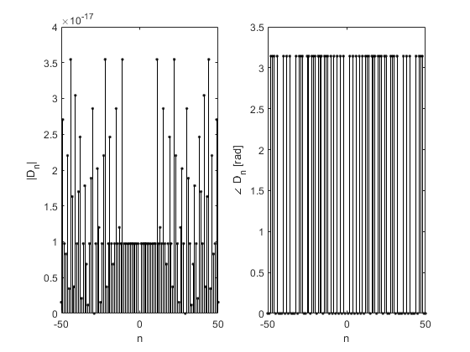

-500 ≤ n ≤ 500

clf; n = (-500:500); D_n = sin(n*pi)./(4*pi*n);  
 subplot(1,2,1); stem(n,abs(D_n),'.k');  
 xlabel('n'); ylabel('|D_n|');  
 subplot(1,2,2); stem(n,angle(D_n),'.k');  
 xlabel('n'); ylabel('\angle D_n [rad]');

